**Develop vector auto regression model for multivariate time series data forecasting**

**EX.No:10**

**DATE:**

**AIM:**

To build a VAR model for forecasting multiple related time series variables.

**ALGORITHM:**

1. Load and preprocess multivariate time series data.
2. Split the data into training and testing sets.
3. Fit the VAR model on the training data.
4. Forecast future values using the fitted model.
5. Evaluate and visualize the forecast results.

**CODE:**

import pandas as pd

import matplotlib.pyplot as plt

from statsmodels.tsa.arima.model import ARIMA

# 1. Load the dataset

df = pd.read_csv('Dataset.csv')

# Keep only the numeric columns

df = df.select_dtypes(include='number')

# Pick the first numeric column

series = df.iloc[:, 0]

# Fill missing values

series = series.ffill()

# 2. Fit ARIMA model

model = ARIMA(series, order=(1,1,1))  # (p,d,q) simple example

model_fitted = model.fit()

# 3. Forecast

n_steps = 5  # predict next 5 points

forecast = model_fitted.forecast(steps=n_steps)

# 4. Plot actual and forecast

plt.figure(figsize=(10,6))

plt.plot(series, label='Actual')

plt.plot(range(len(series), len(series)+n_steps), forecast, '--', label='Forecast', color='red')

plt.title('Actual vs Forecasted')

plt.legend()

plt.xlabel('Time')

plt.ylabel('Value')

plt.grid(True)

plt.show()

**OUTPUT:**

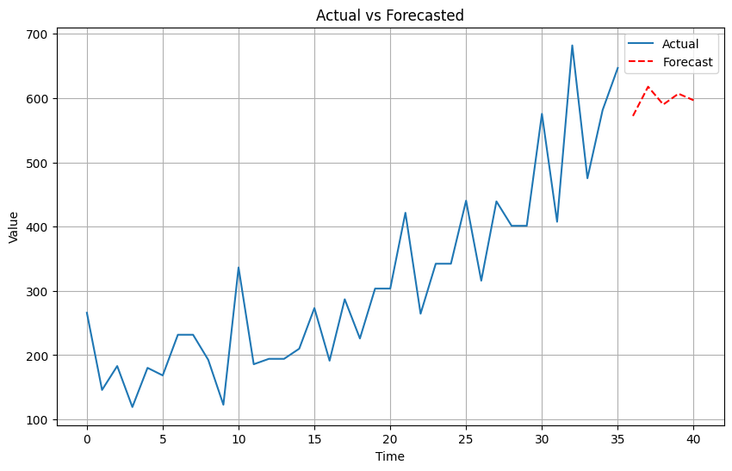

**RESULT:**

Thus the program has been completed and verified successfully.